1.89: Take the length of a side of the cube to be L, and denote the vectors from a to b, a to c and a to d as 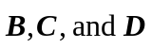. In terms of unit vectors,
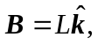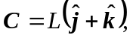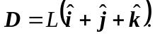

Using Eq. (1.18),
